**DISTRICT – ZOMATO USING JIRA**

1. **WORK ASSIGNED**   
     
   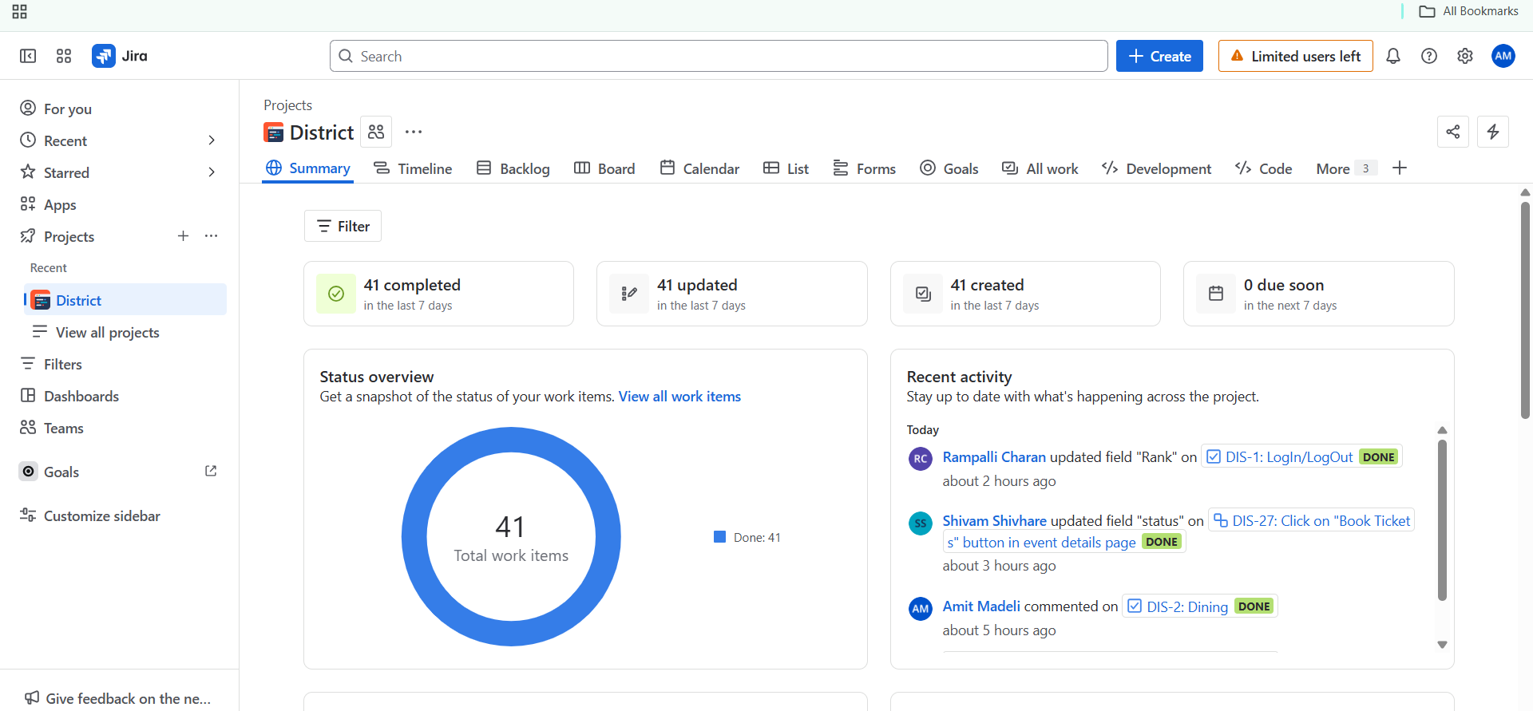
2. **TASKS ASSIGNED TO OUR TEAM**

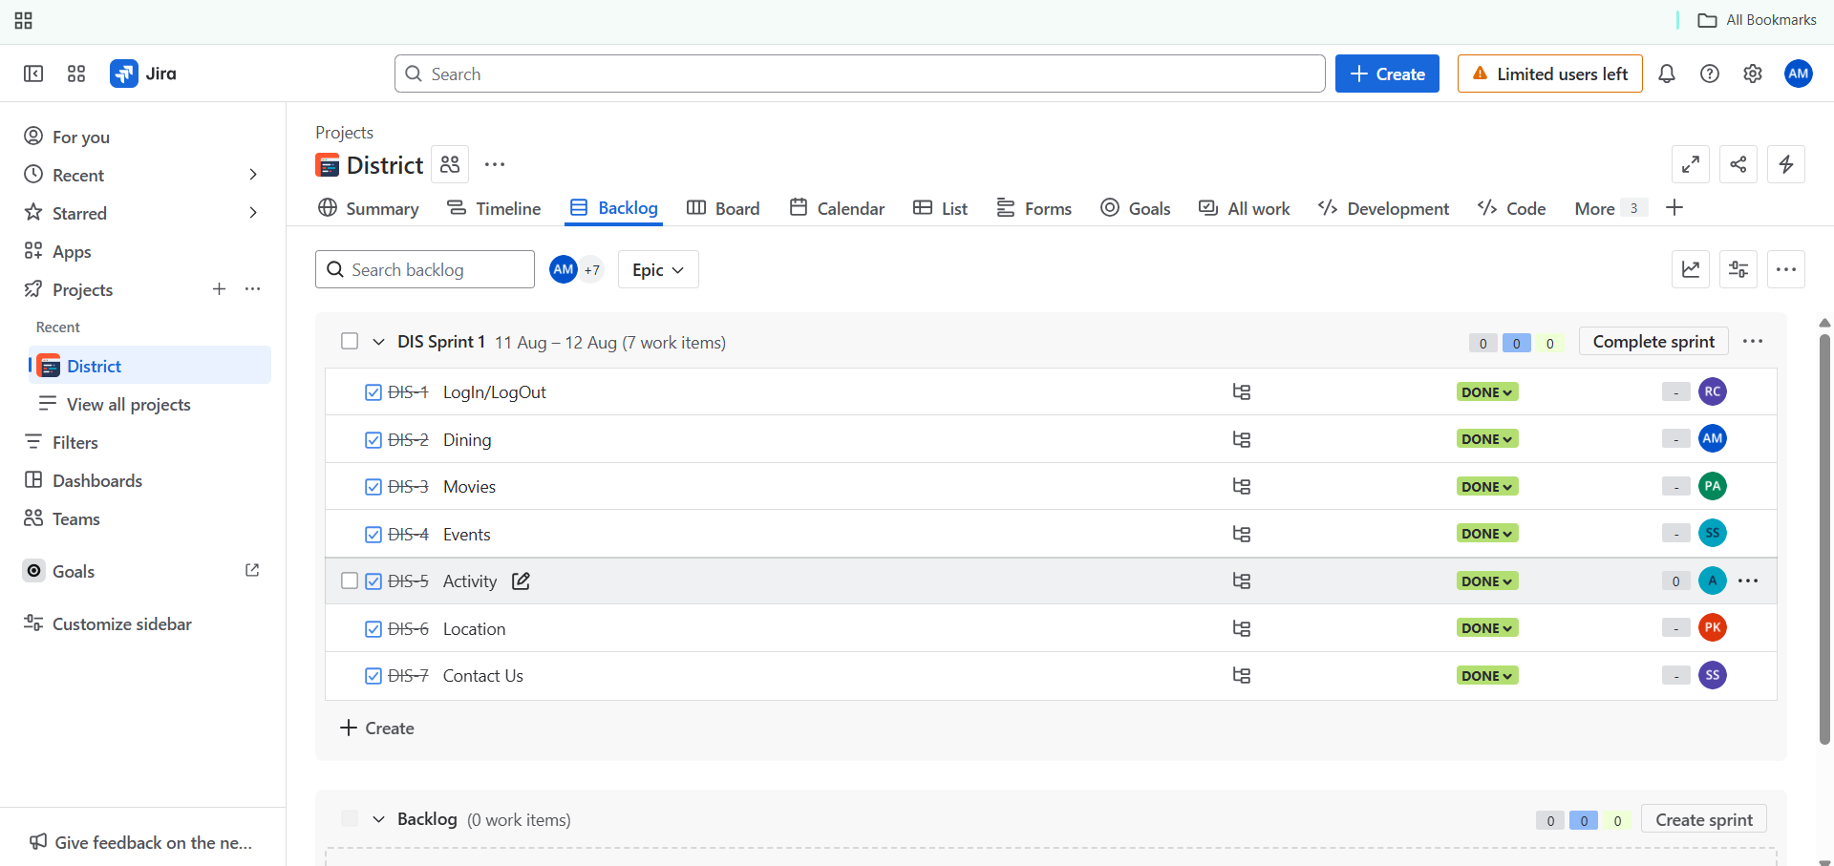

1. **SPRINT STARTED**  
     
     
   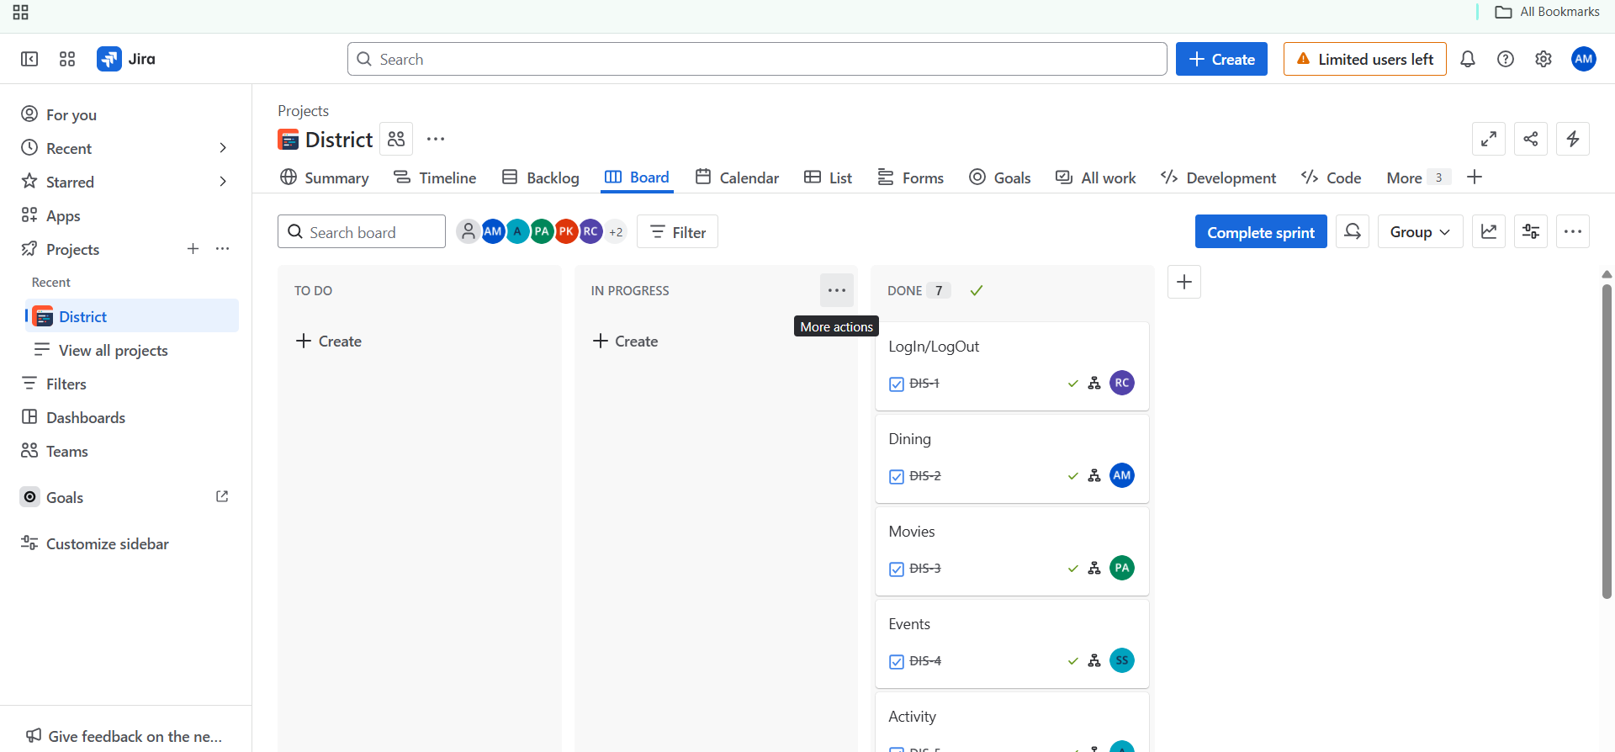
2. **TASKS ASSIGNED TO ME**

